Accessing Brilliant Publications Downloads

Go to https://www.brilliantpublications.education
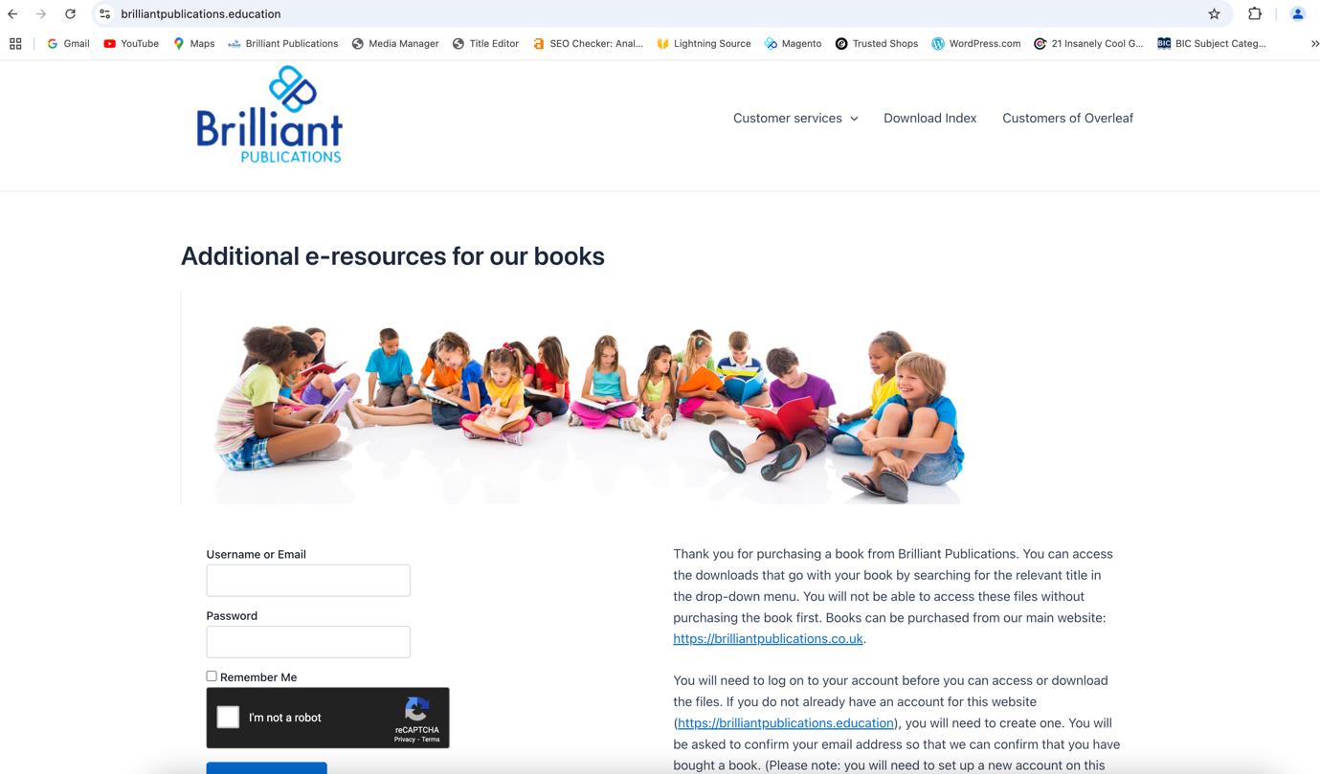

Enter your information to get an authorisation code to access the site. When you press continue the following screen will appear.

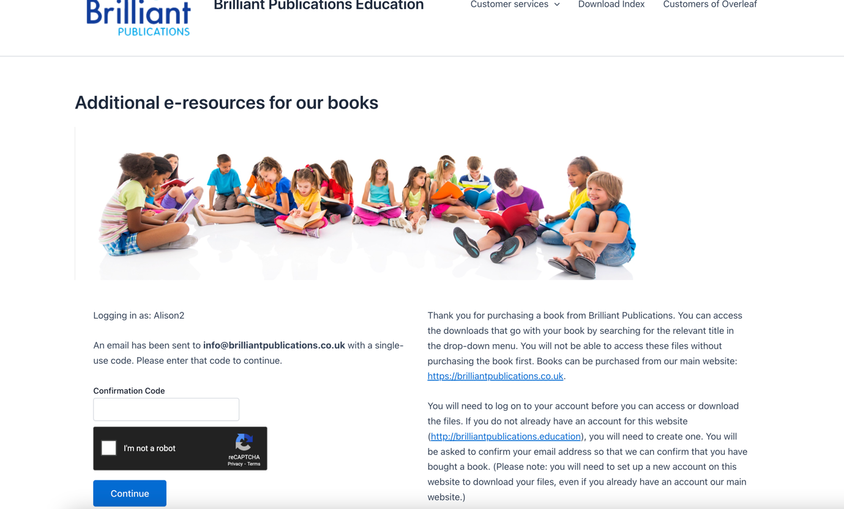
Enter the verification code and tick ‘I’m not a robot’. You will then see the screen of book covers.
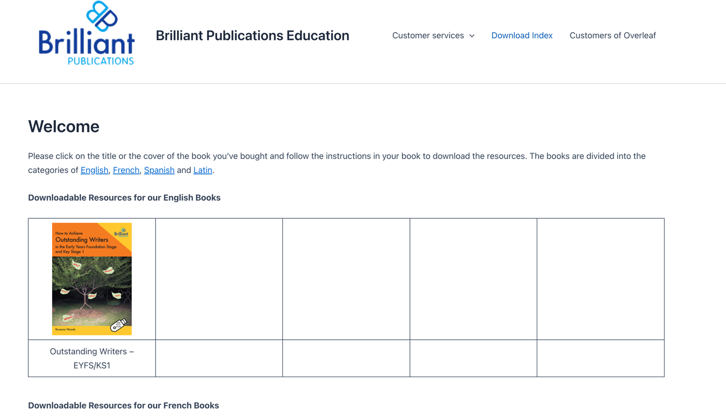

Navigate to the cover of the appropriate book.

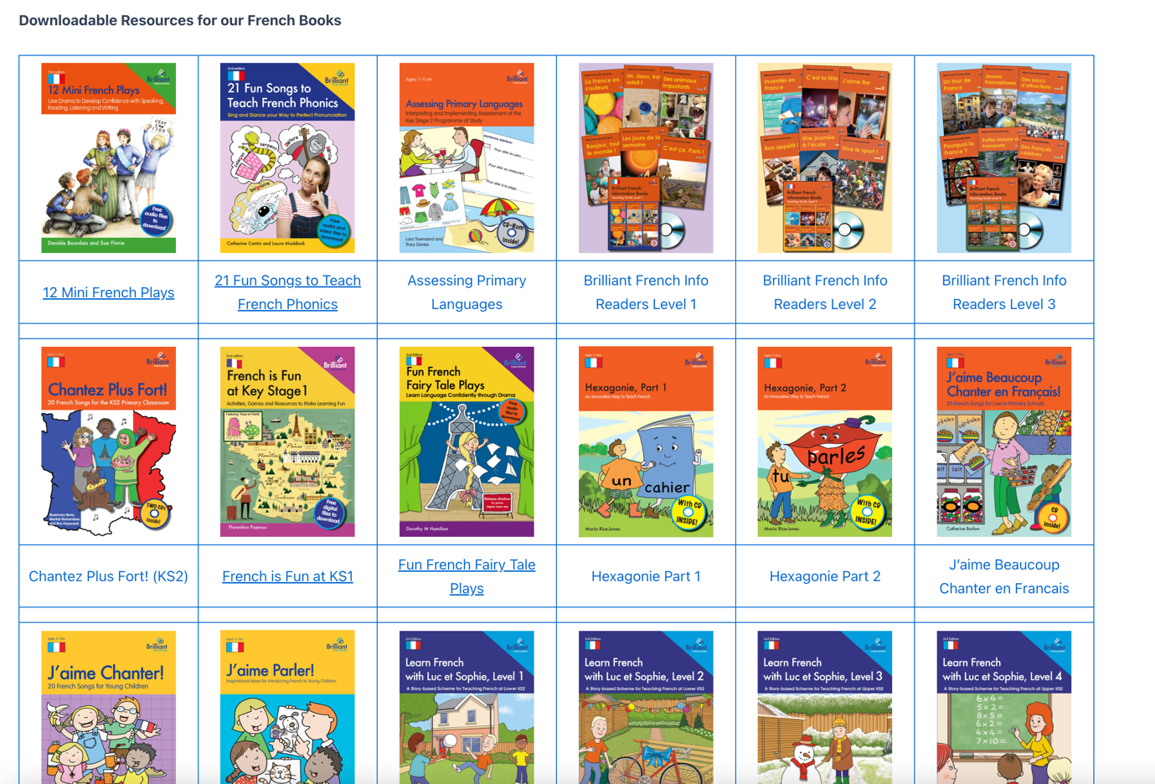

Click on the book title to go to the download page.

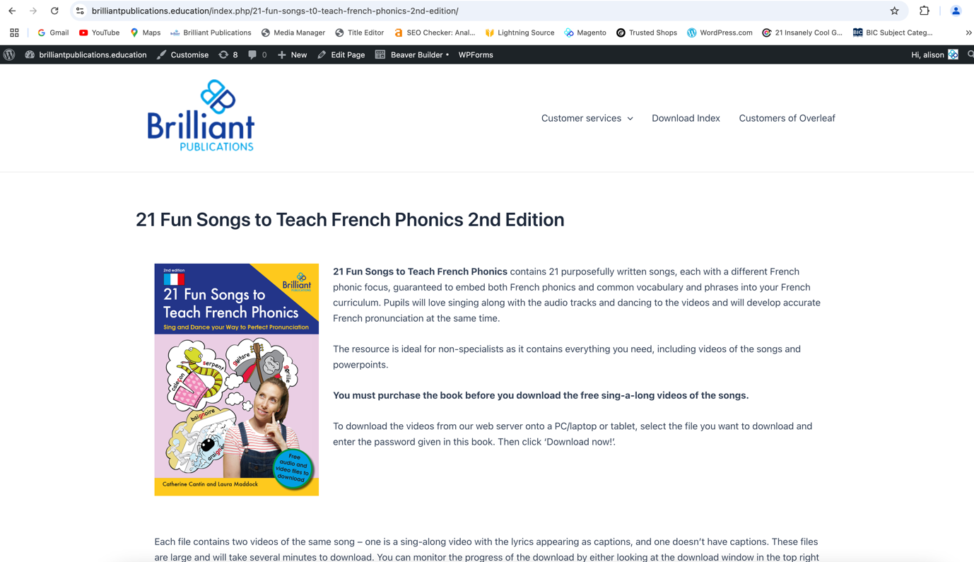

Scroll down the page to find the password entry box

